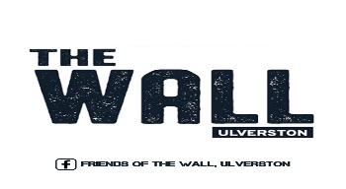
PARENTAL CONSENT FORM
“The WALL recognises that climbing & bouldering are activities with a danger of personal injury or death. Participants in climbing and bouldering activities should be aware of and accept these risks and be responsible for their own actions and involvement.”
THIS PART TO BE FILLED IN BY RECEPTION STAFF
UNDER 14 YEARS OF AGE:
- UNDER 14 YEARS must have written consent of parent/guardian to participate in climbing & bouldering activities & be under the direct in person supervision of a suitably qualified instructor or competent adult member of the wall at all times
Junior Member Name:
Adult contact details:
- 14 – 17 YEAR OLDS Must have written consent of parent / guardian to participate in climbing & bouldering activities. • Must be either; 1. under supervision of a suitably qualified instructor or a competent adult member of the centre at all times. Or 2. unsupervised only after demonstrating basic competencies to an authorised member of staff • Understand and practice bouldering safely.
The basic competence assessment is not an assessment of the young person’s climbing ability, only a limited range of climbing/bouldering techniques, but that they can safely be allowed to boulder unsupervised at the WALL.
PARENT / GUARDIAN CONSENT ALL AGES
I recognise that climbing/bouldering is potentially dangerous activity which I allow (Child Name)……………………………………………………………………….to participate in.
PARENT NAME:
PARENT SIGNATURE:
TELEPHONE NUMBER:
DATE:
UNSUPERVISED CLIMBER ASSESSMENT 14-17 YEARS
STAFF MEMBER NAME: DATE:

